# Report for the Academic Year 2017-18 BHAGVAN MAHAVEER POLYTECHNIC, SURAT

**Diploma in Computer Engineering Final Year Project Report**

**Project Report On**

**Futuristic Home**

# Guided By: Submitted By:

##### Ms. Payal Bodawala Adishesh Mishra (146080307001) Amiralam Ansari (156080307002)

**Harsh Maheshwari (156080307045)**



**CERTIFICATE**

*This is to certify that Mr.* ***(Adishesh Mishra, Amiralam Ansari, Harsh Maheshwari)*** *from* ***Bhagwan Mahavir college of Polytechnic*** *having Enrollment No: (****146080307001,156080307002,156080307045)*** *has completed* ***Final Year Project Report*** *Having title (****Futuristic Home)*** *in a group consisting of* ***(4)*** *persons under the guidance of the Faculty Guide* ***(Ms. Payal Bodawala).***

*Faculty Guide Head of Department*

# ACKNOWLEDGEMENT

Every project is masterpiece of hard work and sincere effort of all those who are involved in the project. We are grateful to all of them who were a part of our hard work and would definitely be an inevitable part of our success.

This project work is an integrated effort of all those, concerned through the project whose co- operative and effective guidance helped us to complete the project work.

We take this opportunity to express our profound gratitude and deep regards to our guide **Miss Payal Bodawala** for her exemplary guidance, monitoring and constant encouragement

throughout the course of this thesis. The blessing, help and guidance given by her time to time shall carry us a long way in the journey of life on which we are about to embark.

We are obliged to staff members of **Bhagwan Mahavir College of Polytechnic**, for the valuable information provided by them in their respective fields. I am grateful for their cooperation during the period of our assignment.

This was the step towards the career in IT. It was the great experience of exposing and learning new things in this field. Last, but not the least we take the opportunity to thank all those people who have help directly or indirectly in making our project feasible and turn it to a successful piece of work.

# With Regards,

Adishesh Mishra Amiralam Ansari Harsh Maheshwari

# ABSTARCT

Today world is a global hub due to advancements in technology. Inventions and evolution in technology have made this possible. Home automation has an important role in people’s life when it comes to their standard of living as it provides convenient and hassles free environment. In this project, we have designed an affordable and simple to use the system that takes the input from the ANDROID APP send through Wi-Fi & Provide Entrance Security Using Finger Print Access, monitor hazardous environment conditions, including toxic gasses through GSM modem. Also measure room temperature and temperature is high to define limit so AC or fan or other cooling equipment operate automatically. Home or house passage light also operate automatically base on sun light. So project handle automatically and work base on real life technologically. Also, the smart home concept in the system improves the standard living at home.

# INDEX

|  |  |  |
| --- | --- | --- |
| **Ch. No.** | **Content** | **Page No.** |
| **1** | Introduction | 1 |
| **2** | Problem definition | 5 |
| **3** | Description of the product and problem analysis | 6 |
|  | 3.1 Model | 6 |
|  | 3.2 Hardware requirement | 9 |
|  | 3.3 Software requirement | 9 |
| **4** | The outline of the solution | 10 |
|  | 4.1 Data Dictionary | 10 |
|  | 4.2 ER Diagram | 12 |
|  | 4.3 DFD | 13 |
| **5** | Snapshot | 15 |
| **6** | Test strategies and cases | 19 |
| **7** | Application, Advantages and Disadvantages | 22 |
| **8** | Conclusion | 23 |
| **9** | Future enhancement | 24 |
|  | Bibliography |  |





## INTRODUCTION

* World has been change a lot, like we were all using.

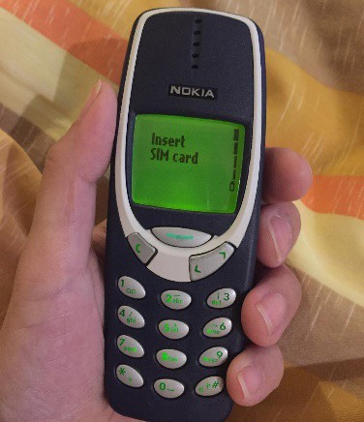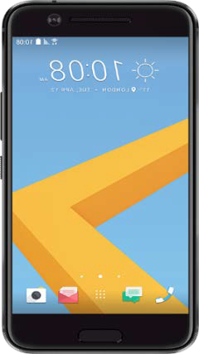

Keypad Phone Smart Phone

* On Single Click we can do Transactions of Crores, so when our phone gets developed this much why can’t our Home can be more Smart.

* Home automation has an important role in people’s life when it comes to their standard of living as it provides comfort zones.

1.1 **Background**

Home automation has made it possible to have what is often referred to as a 'smart home', a home that can detect and identify you, automatically adjust the lighting to your predefined taste, open doors automatically, play your favorite music, water your flowers in the morning, switch on the security lights at night and switch them off in the morning, heat water for bathe and tea, stream to you anywhere in the world via the internet a live video of what is happening in and around your house.

The “Home Automation” concept has existed for many years. The terms “Smart Home”, “Intelligent Home” followed and has been used to introduce the concept of networking appliances and devices in the house. Home automation Systems (HASs) represents a great



1

research opportunity in creating new fields in engineering, and Computing. HASs includes centralized control of lighting, appliances, security locks of gates and doors and other systems, to provide improved comfort, energy efficiency and security system. HASs becoming popular nowadays and enter quickly in this emerging market. However, end users, especially the disabled and elderly due to them complexity and cost, do not always accept these systems.

Due to the advancement of wireless technology, there are several different of connections are introduced such as GSM, WIFI, and Bluetooth. Each of the connection has their own unique specifications and applications. Among the four popular wireless connections that often implemented in HAS project, WIFI is being chosen with its suitable capability. The capabilities of WIFI are more than enough to be implemented in the design. Also, most of the current laptop/notebook or Smartphone come with built-in WIFI adapter. It will indirectly reduce the cost of this system.

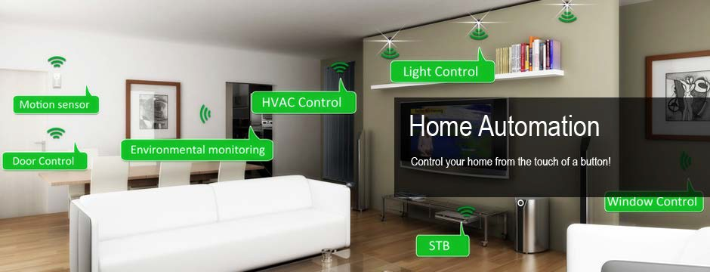

Home Automation



2

# Project Objectives

### Entrance Security

* Traditional Locks can be broken or Sometimes we lose our keys so it become a problem, so Fingerprint Based Security System is Secure & Safe Modern Technology

### Safety System

* In Current Phases When Technology is Growing at a Rapid Speed, safety system also need to be Updated.

* Gas sensors, small like a nose, gas sensors spontaneously react to the gas present.

* Gas sensor are available in market but what if you are not at home the sensor will be none of use if don’t know if gas leak is their.

* So, we add a GSM module to our Gas Sensor so we can get Message if their a gas leak

### Temperature Automation

* Assume it a Hot Afternoon in April and when you come Home from office, House is Automatically Cooled

* We don’t need to adjust temperature in our Home * Temperature will be adjust by sensors.

### Light Automation

* Everyday a Headlines or New to Save Energy or Uses wisely, but we all know human are a bit lazy so many times we start our corridor lights or Garden’s light.

* So we will use light sensor that will automatically turn on and off light according to light density in Environment



# Scopes

The project aims at designing a prototype for controlling the home appliances that can be controlled wirelessly via an application that provides the features of speech recognition, video streaming, and switch mode. An application is run on android device. The system can be used in wide range of areas. The system integrated with different features can be applied in the following fields.

##### The system can be used in home, small offices to the big malls

The system can be used from home to offices to control the electrical appliances.

##### For remote access of appliances in internet or intranet.

The home/office appliances can be controlled in intra-network or can be accessed via internet.

##### For the development of technology friendly environment

The system incorporates the use of technology and making smart home automation. By the use of day to day gadgets we can utilize them for different prospective.







PROBLEM DEFINITION

* Most Advanced home automation systems in existence today require a big and expensive change of infrastructure. This means it often is not feasible to install a home automation system in an existing building. The Home automation is a wireless home automation system that is supposed to be implemented in existing home environments, without any changes in the existing infrastructure. Home automation lets user to control his home from his or her computer.

* When we can do transactions of Crores on a Click than why we should struggle to switch of light, Home automation is available in market but this much more complicated for a non-techie person.

* Day by day Energy Crisis is rising so we have light automation so we can save energy in Day Time.

* Due to Global warming temperature can’t predicted as Sometimes it too hot or too cold, so for this issue we have temperature Automation it will automatically adjust temperature for house.

* Gas Alarm are available in market but what if you are not at home and Gas leak happen so alarm will none of uses. So we make a new system that will sense Gas leak and Alarm us but with this we have added a GSM module so that suppose we are out of house we will get to known.



## DESCRIPTION OF THE PRODUCT AND PROBLEM ANALYSIS

### MODEL

This software is developed by following “Waterfall Model‟.



Requirement Analysis

System Design

Implementation

System Testing

System Deployment

System Maintenance

Fig. Waterfall model



6



7

|  |  |  |  |
| --- | --- | --- | --- |
| **S.No** | **Phase** | **Activities Performed** | **Deliverables** |
| 1 | Requirement Analysis | 1. Capture all the requirements. 2. Do brainstorming and walkthrough to understand the requirements. 3. Do the requirements feasibility test to ensure that the requirements are testable or not. | RUD ( Requirements Understanding Document) |
| 2 | System Design | 1. As per the requirements, create the design 2. Capture the hardware / software requirements. 3. Document the designs | HLD ( High Level Design document)  LLD (Low level design document) |
| 3 | Implementation | 1. As per the design create the programes / code 2. Integrate the codes for the next phase. 3. Unit testing of the code | Programs  Unit test cases and results |
| 4 | System Testing | 1. Integrate the unit tested code and test it to make sure if it works as expected. 2. Perform all the testing activities (Functional and non functional) to make sure that the system meets the requirements.   1. In case of any anomaly, report it. 2. Track your progress on testing through tools like traceability metrics, ALM 3. Report your testing activities. | Test cases Test reports Defect reports  Updated matrices. |
| 5 | System Deployment | 1. Make sure that the environment is up 2. Make sure that there are no sev 1 defects open. 3. Make sure that the test exit criteria are met. 4. Deploy the application in the respective environment. 5. Perform a sanity check in the environment after the application is deployed to ensure the application does not break. | User Manual  Environment definition / specification |
| 6 | System maintenance | 1. Make sure that the application is up and running in the respective environment. 2. Incase user encounters and defect, make sure to note and fix the issues faced. 3. Incase any issue is fixed; the updated code is deployed in the environment. 4. The application is always enhanced to incorporate more features, update the | User Manual  List of production tickets  List of new features implemented. |

# When to use SDLC Waterfall Model?

SDLC Waterfall model is used when

**Requirements are stable and not changed frequently. Application is small.

**There is no requirement which is not understood or not very clear. The environment is stable

**The tools and technology used is stable and is not dynamic Resources are well trained and are available.

### Advantages of using Waterfall model are as follows:

*Simple and easy to understand and use.

**For smaller projects, waterfall model works well and yield the appropriate results. Since the phases are rigid and precise, one phase is done one at a time , it is easy to maintain.

*The entry and exit criteria are well defined, so it easy and systematic to proceed with quality.

*Results are well documented.

##### Disadvantages of using Waterfall model:

*Cannot adopt the changes in requirements

*It becomes very difficult to move back to the phase. For example, if the application has now moved to testing stage and there is a change in requirement, It becomes difficult to go back and change it.

*Delivery of the final product is late as there is no prototype which is demonstrated intermediately.

**For bigger and complex projects, this model is not good as risk factor is higher. Not suitable for the projects where requirements are changed frequently.

*Does not work for long and ongoing projects.

*Since the testing is done at later stage, it does not allow identifying the [challenges and](http://www.softwaretestinghelp.com/types-of-risks-in-software-projects/) [risks](http://www.softwaretestinghelp.com/types-of-risks-in-software-projects/)in the earlier phase so the risk mitigation strategy is difficult to prepare.



### Hardware requirements

 Arduino

 Gas Sensor

 Temperature sensor  Light Sensor

 Fingerprint Sensor

 Mobile (Android OS)

### Software Requirements

 Arduino Compiler

 MC Programming Language  Android Studio







THE OUTLINE OF THE SOLUTION

### Data Dictionary

* User :

|  |  |  |  |
| --- | --- | --- | --- |
| **Column Name** | **Datatype** | **Constrain** | **Is Null** |
| **U_id** | Varchar(30) | Primary Key | - |
| **U_name** | Varchar(30) | - | - |
| **Mobile No.** | INT(10) | - | - |

#### * Mobile :

|  |  |  |  |
| --- | --- | --- | --- |
| **Column Name** | **Datatype** | **Constrain** | **Is Null** |
| **M_id** | Varchar(30) | Primary Key | - |
| **U_id** | Varchar(30) | Foreign Key | - |
| **App** | Byte | - | - |

* Bio-Metric Storage :

|  |  |  |  |
| --- | --- | --- | --- |
| **Column Name** | **Datatype** | **Constrain** | **Is Null** |
| **B_id** | Varchar(30) | Primary Key | - |
| **U_id** | Varchar(30) | Foreign Key | - |
| **Finger_print** | BLOB | - | - |



#### * Sensor :

|  |  |  |  |
| --- | --- | --- | --- |
| **Column Name** | **Datatype** | **Constrain** | **Is Null** |
| **S_id** | VARCHAR(30) | Primary Key | - |
| **B_id** | VARCHAR(30) | Foreign Key | - |
| **Light** | Byte | - | - |
| **Temperature** | Byte | - | - |
| **Gas** | Byte | - | - |



### ER-Diagram

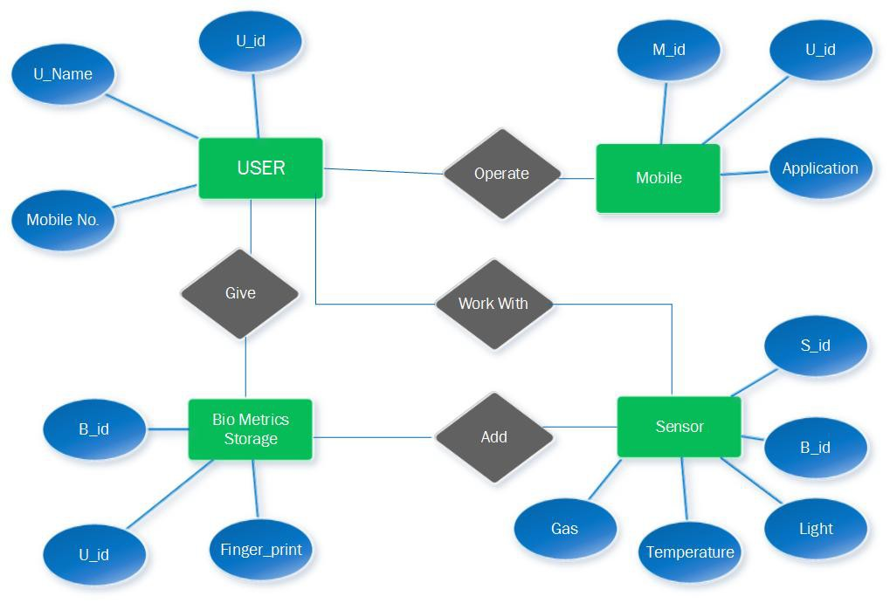



### DFD (Data Flow Diagram)

#### LEVEL 0:

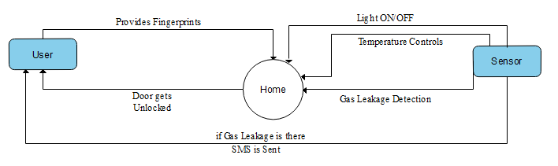



#### LEVEL 1: -

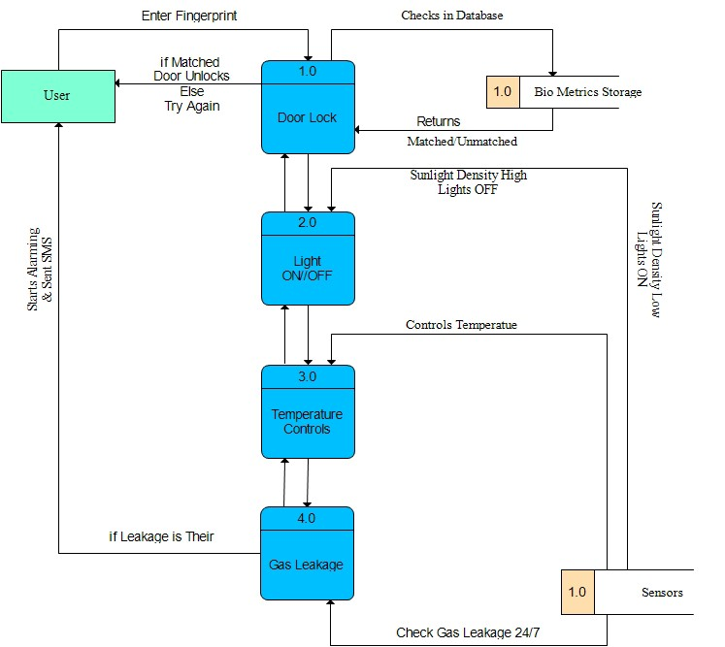







# SNAPSHOTS

#### Futuristic Home

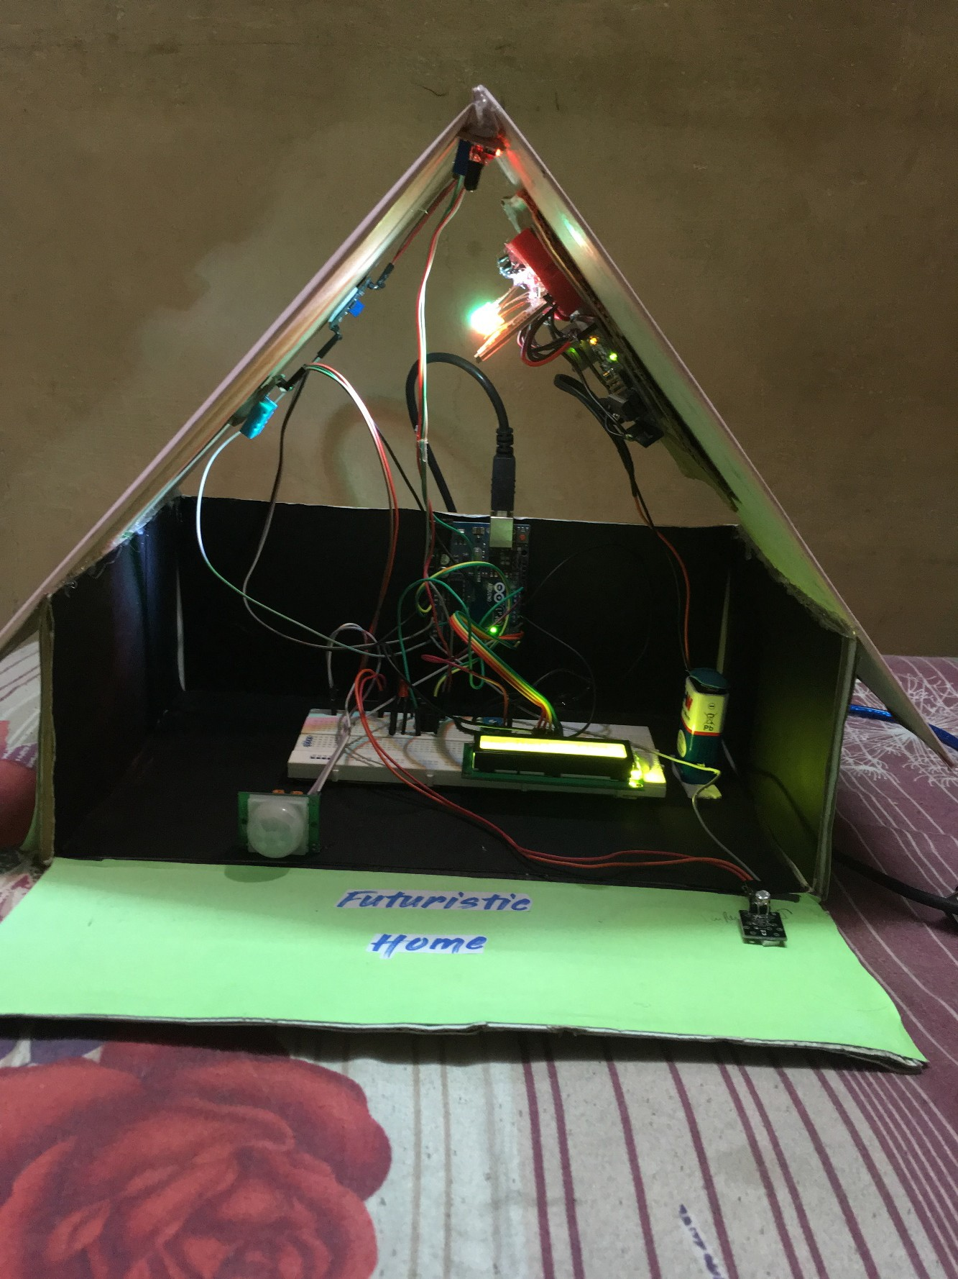



**Different Modules**

#### LDR :

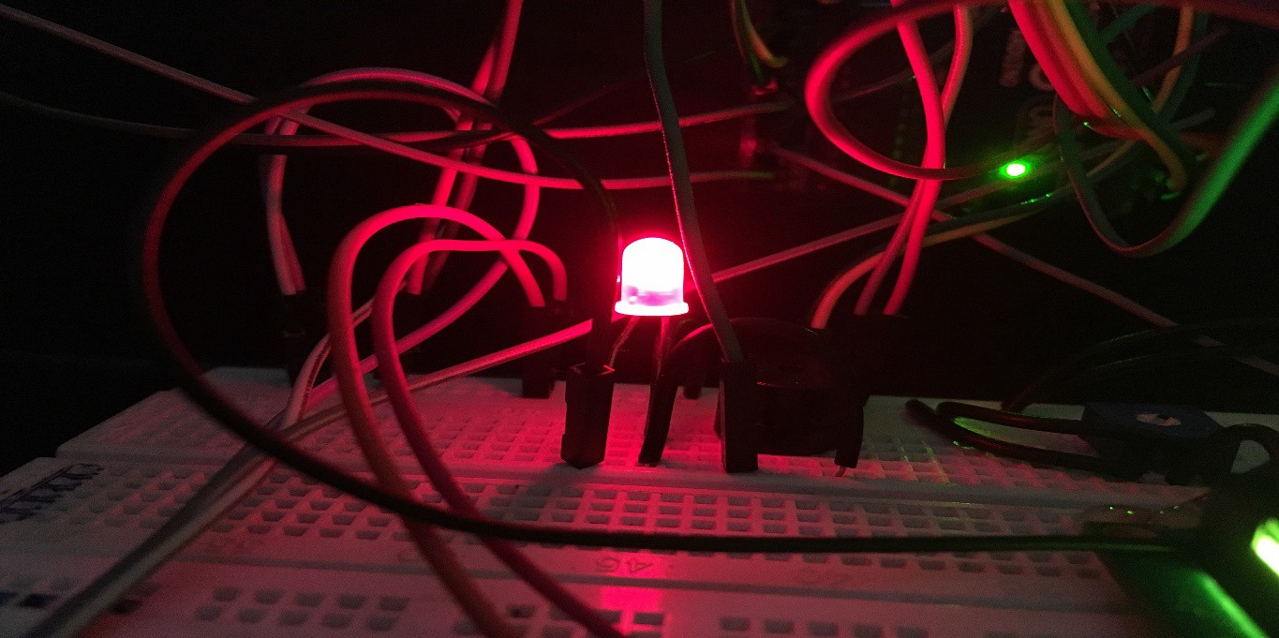

Theft Find

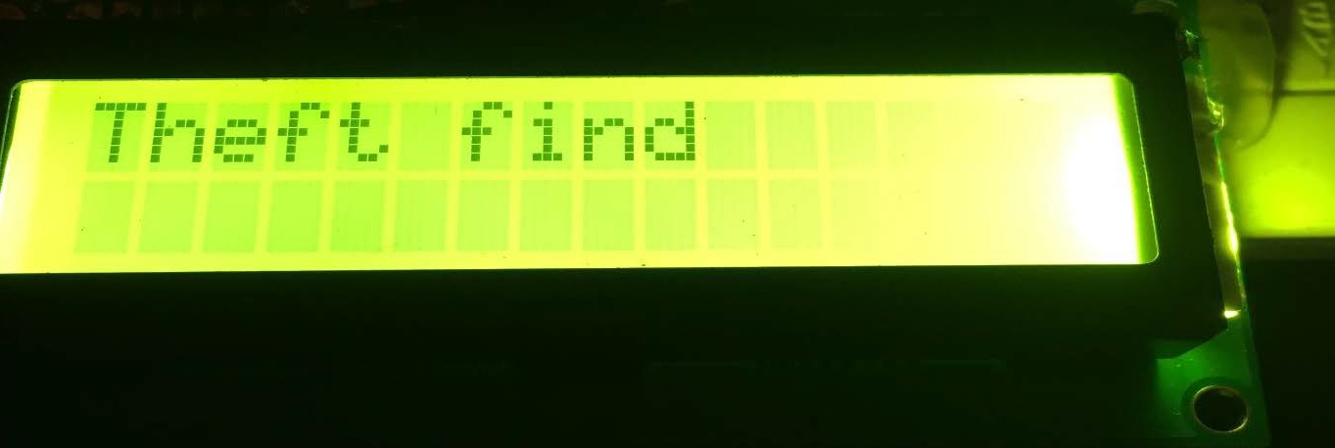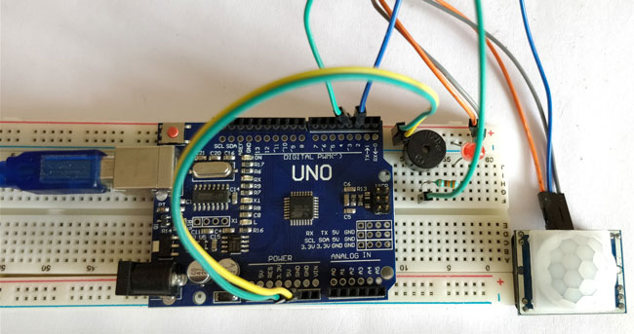

No Fire

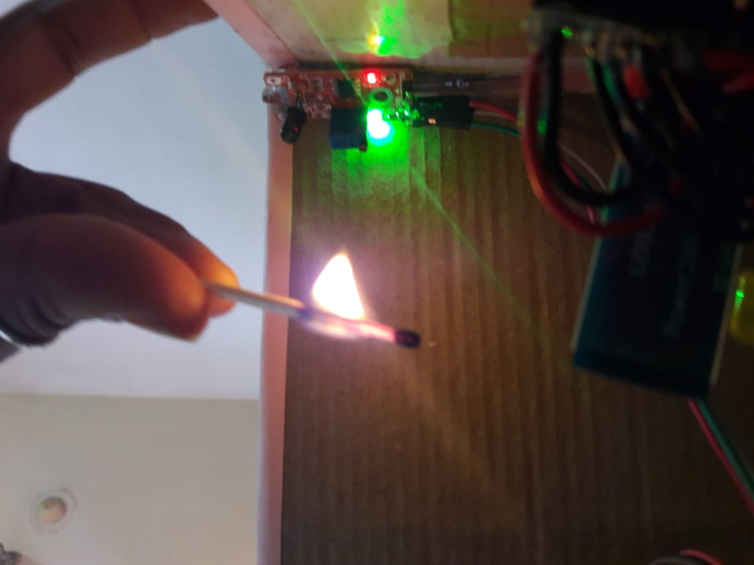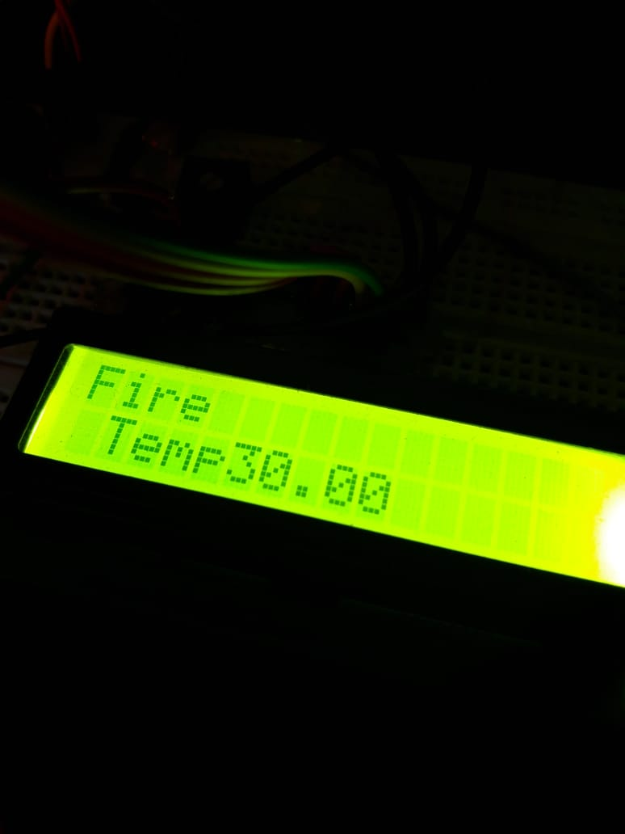



#### Home Automation

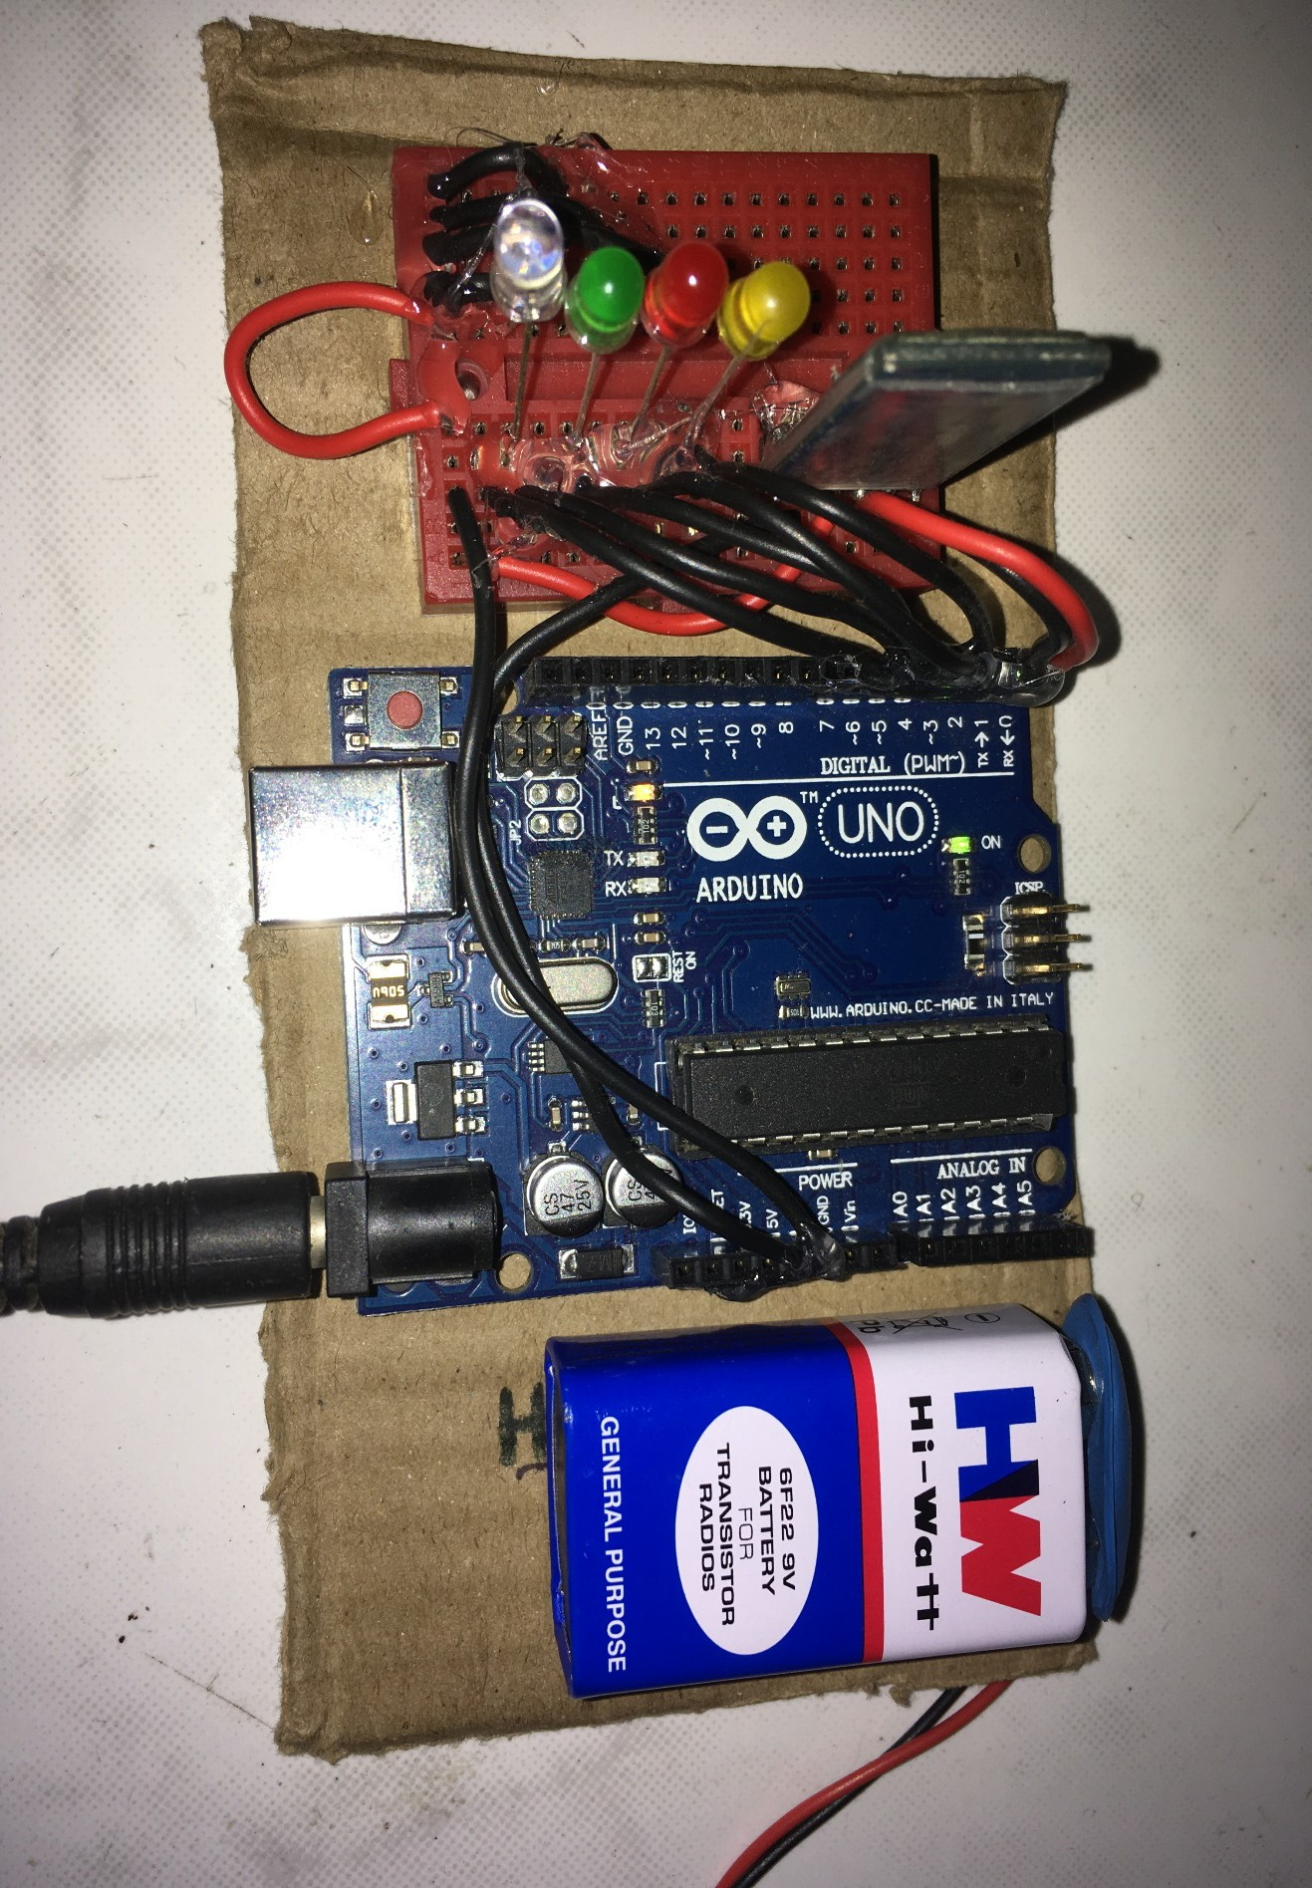



#### Working

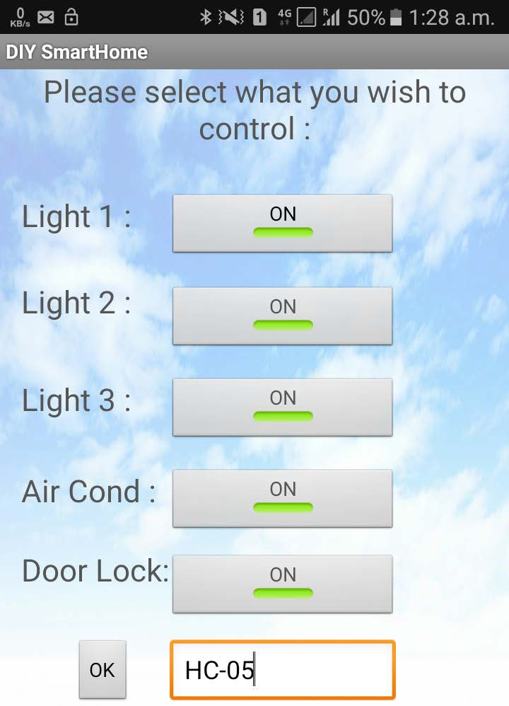

Output

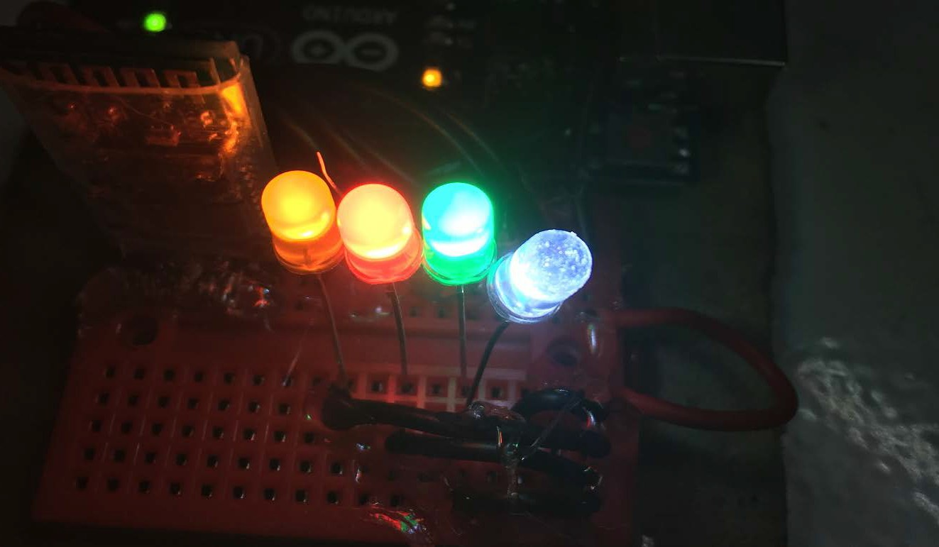







# TEST STRATEGIES AND CASES

Any developed computer software may subject to failure due to errors in its engineering process. Testing is a process of executing a program with the intent of finding an error. It is a process of verification and validation often used interchangeably. “Validation” is the process of evaluating the software at the end of software development to ensure compliance with the software requirements. Testing is a common method of validation.

##### Unit Testing

Unit testing was used to test individual units in the system and ensure that they operate correctly. Alternate logic analysis and screen validation were tested in this phase to ensure optimum efficiency in the system. The procedures and functions used and their association with data were tested.

##### Module Testing

Module testing was used to ensure that the dependable components in a module work in coordination with another. Function testing, performance testing and stress test were conduct on modules independently to ensure robustness in the system developed. The various forms, their validations, relationships between forms, tables and the data flows between components in a module were analyzed and tested. The procedures and functions common to a module were also tested during module testing.

##### Module Testing

Sub-system testing also known as integration testing was used to ensure that the modules are available for integration with one another to form the final integrated system. Interface testing was conducted to ensure that the module could work in harmony with one another. The relationship between the modules and the data they share were tested.



**Test Strategies: -**

##### White Box Testing

**White Box Testing** (also known as Clear Box Testing, Open Box Testing, Glass Box Testing, Transparent Box Testing, Code-Based Testing or Structural Testing) is a [software](http://softwaretestingfundamentals.com/software-testing-methods/) [testing method](http://softwaretestingfundamentals.com/software-testing-methods/) in which the internal structure/ design/ implementation of the item being tested is known to the tester. The tester chooses inputs to exercise paths through the code and determines the appropriate outputs. Programming know-how and the implementation knowledge is essential. White box testing is testing beyond the user interface and into the nitty- gritty of a system.

This method is named so because the software program, in the eyes of the tester, is like a white/ transparent box; inside which one clearly sees.

* + **White-box testing:** Testing based on an analysis of the internal structure of the component or system.
  + **White-box test design technique:** Procedure to derive and/or select test cases based on an analysis of the internal structure of a component or system.

##### LEVELS APPLICABLE TO

White Box Testing method is applicable to the following levels of software testing:

* + [Unit Testing](http://softwaretestingfundamentals.com/unit-testing/): For testing paths within a unit.
  + [Integration Testing](http://softwaretestingfundamentals.com/integration-testing/): For testing paths between units.
  + [System Testing](http://softwaretestingfundamentals.com/system-testing/): For testing paths between subsystems.



##### Black Box Testing

**Black Box Testing**, also known as Behavioral Testing, is a [software testing method](http://softwaretestingfundamentals.com/software-testing-methods/) in which the internal structure/ design/ implementation of the item being tested is not known to the tester. These tests can be functional or non-functional, though usually functional.

This method is named so because the software program, in the eyes of the tester, is like a black box; inside which one cannot see. This method attempts to find errors in the following categories:

* + Incorrect or missing functions
  + Interface errors
  + Errors in data structures or external database access
  + Behavior or performance errors
  + Initialization and termination errors
  + **Black Box Testing:** Testing, either functional or non-functional, without reference to the internal structure of the component or system.
  + **Black Box Test Design Technique:** Procedure to derive and/or select test cases based on an analysis of the specification, either functional or non-functional, of a component or system without reference to its internal structure.

##### LEVELS APPLICABLE TO

Black Box Testing method is applicable to the following levels of software testing:

* + [Integration Testing](http://softwaretestingfundamentals.com/integration-testing/)
  + [System Testing](http://softwaretestingfundamentals.com/system-testing/)
  + [Acceptance Testing](http://softwaretestingfundamentals.com/acceptance-testing/)







# Advantages & Disadvantage:

### Advantages:

* User Friendly, it is going to work on Android and nowadays all know how to use Android phone, so need to learn how to use this App or How can this all work

* Customization, you can Automated part of house you want to it up to you want you want to Automate and what not to

* Security, Biometrics Gives you a better and efficient security rather than a traditional lock

* Ease to install not need a technician to install

### Disadvantages:

* Biometric System, if fingerprint got cuts than you will be locked in your house * Learning, New Technology will take time to adopted by peoples

* Reliability, this is based on wireless so it is less reliable sometimes.



22









# Conclusion:

Home Automation is undeniably a resource, which can make a home environment automated. People can control their electrical devices via these Home Automation devices and set up the controlling actions in the computer. We think this product have High potential for marketing in the future. At the moment the components are a bit too high to be able to produce these devices for an interesting price.



# Future enhancement

* Automatically turns motor On/Off according to water level in tank * Motion sensing light

* Cloud computing. * Solar Powering.



## Bibliography

##### Web References:

* https://[www.quora.com/What-is-home-automation](http://www.quora.com/What-is-home-automation)

* <https://www.quora.com/Is-the-Internet-of-Things-all-about-home-automation>* <https://www.quora.com/What-is-the-future-scope-of-home-automation>

* <http://in.pcmag.com/digital-home/67193/feature/the-best-smart-home-devices-of2017>* <https://www.pcmag.com/article/344336/the-best-smart-locks>

##### Book References:

* Android App Development for Dummies By: Michael Burton

##### E-Book References:

* Arduino for Dummies By: John Nussey